First of all to selecte an item :

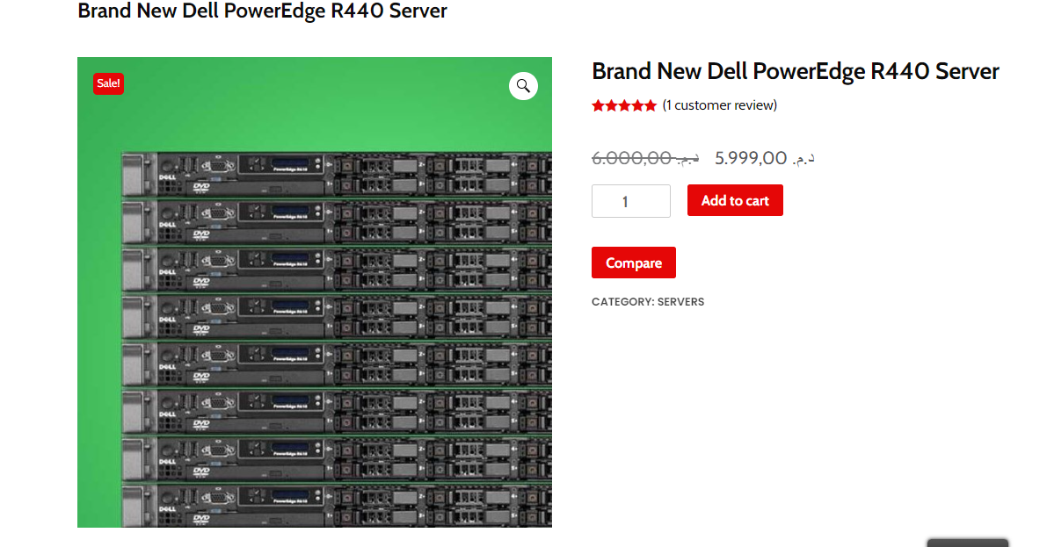

Secand you need to click on the button add to card:

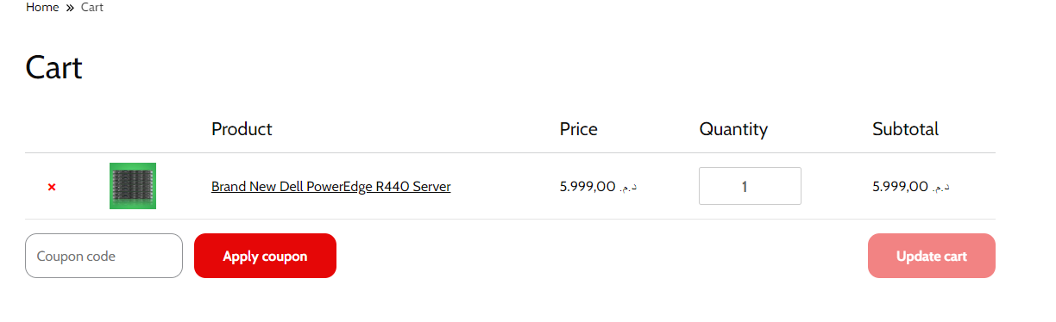

Then you need to fill your information 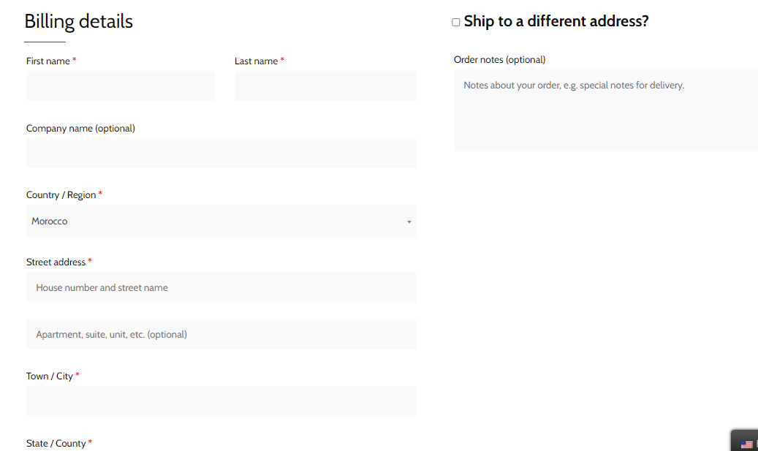

And you hit the button submit to confirm your ordre

